STAT 337 HW 3: SLR inference and transformations
Lucas Jones
Due Friday, April 10th, 2026, by 11:59pm
knitr::opts_chunk$set(echo = TRUE)
options(show.signif.stars = FALSE)

Background
Electric vehicles (EVs) have become increasingly common in recent years as consumers and policymakers look for alternatives to gasoline-powered transportation. Although they have environmental and ethical impacts related to mining for materials and manufacturing lithium-ion batteries, they turn electricity into power rather than by using fossil fuels and thus have no tailpipe emissions. Zero-emissions alternatives to gas and diesel powered vehicles promise to improve air quality in urban areas and have an overall positive impact on public heath. As adoption of EVs grows, understanding factors related to EV performance, cost, and efficiency becomes increasingly important. This dataset provides an opportunity to explore relationships between key EV characteristics.
For this homework, we are going to explore the relationship between EV top speed (km/h) and the time to accelerate from 0 to 100 km/h. Specifically, we will use simple linear regression skills to describe the relationship between true mean top speed and acceleration. We will use this kaggle dataset https://www.kaggle.com/code/devraai/ev-performance-and-battery-data-analysis/input on EVs to investigate our questions of interest!
We will consider the following subset of variables:
- drivetrain: the drivetrain of the vehicle (all wheel drive AWD, front wheel drive FWD, rear wheel drive RWD).
- battery_capacity_kWh: Total energy storage of the battery (kWh).
- efficiency_wh_per_km: Energy consumed per kilometer (Wh/km).
- top_speed_kmh: Maximum speed of the car which it can achieve (km/h).
- acceleration_0_100_s: Time required to reach 100 km/h from rest (sec).
- range_km: Maximum distance the vehicle can travel on a full charge (km).

Variables and Hypotheses
Suppose Katie (the STAT 337 course supervisor) claims that the following model is appropriate for investigating the research question of interest. $top_speed_{i}=β_{0}+β_{1}acceleration_{i}+ϵ_{i}; ϵ_{i}∼N(0,σ^{2})$
You’re inclined to trust her due to her position as course supervisor, so you don’t immediately question her hasty approach.
- (2 pts) Which parameter in Katie’s model would allow you to investigate the research question? Briefly explain your reasoning.
- The parameter in Katie’s model that would allow me to investigate the research question is B1/the slope.
Katie now presents you with the following output and demands that you use the output to answer the following questions
# load packages
library(tidyverse)
library(patchwork)
# read in the data and select variables mentioned above
# also transform drivetrain to a factor
ev_data <- read_csv("electric_vehicles_spec_2025.csv")
# data frame we want to use is now called "df_ev"
df_ev <- ev_data %>%
select(drivetrain, battery_capacity_kWh,
efficiency_wh_per_km, top_speed_kmh,
acceleration_0_100_s, range_km) %>%
mutate(drivetrain = factor(drivetrain))
# Katie fits this slr...
fit_speed <- lm(top_speed_kmh ~ acceleration_0_100_s, data = df_ev)
summary(fit_speed)
##
## Call:
## lm(formula = top_speed_kmh ~ acceleration_0_100_s, data = df_ev)
##
## Residuals:
## Min 1Q Median 3Q Max
## -43.946 -14.229 -3.673 12.661 96.310
##
## Coefficients:
## Estimate Std. Error t value Pr(>|t|)
## (Intercept) 256.5778 2.4152 106.24 <2e-16
## acceleration_0_100_s -10.3289 0.3262 -31.66 <2e-16
##
## Residual standard error: 19.46 on 476 degrees of freedom
## Multiple R-squared: 0.6781, Adjusted R-squared: 0.6774
## F-statistic: 1003 on 1 and 476 DF, p-value: < 2.2e-16
confint(fit_speed)
## 2.5 % 97.5 %
## (Intercept) 251.83211 261.323474
## acceleration_0_100_s -10.96995 -9.687937
- (6 pts) Write out the estimated model. Also provide an estimate for the residual standard deviation and describe what part of the model it characterizes in your own words.
- Estimated model: 256.5778 - 10.3289(acceleration_0_100_s) $$
- $\hat{σ}=$ 19.46
- (8 pts) Use the model to predict the top speed for an EV that accelerates from 0 to 100 km in 15 seconds. Show all your work and interpret your answer in the context of the problem.
- Prediction: 256.5778 - 10.3289(15) = 101.6443km/h $$
- The estimated top speed for an EV that accelerates from 0 to 100km in 15 seconds is 101.6443km/h.
- (4 pts) Provide an interpretation of the 95% CI for the “slope” parameter in the context of the problem.
- We are 95% confident that for each 1 second increase in acceleration from 0 to 100km, the top speed of the EV will decrease by an amount somewhere between 10.9700 and 9.6880
You’re really beginning to question Katie’s judgement here and before you go any further you decide to make some diagnostic plots.
# split plotting window into 4 panels
# Note: to make a 2x2 grid, change c(1,4) to c(2,2)
par(mfrow = c(1,4))
# make diagnostic plots
plot(fit_speed, pch = 19, col = rgb(0.2,0.2,0.2, 0.5))
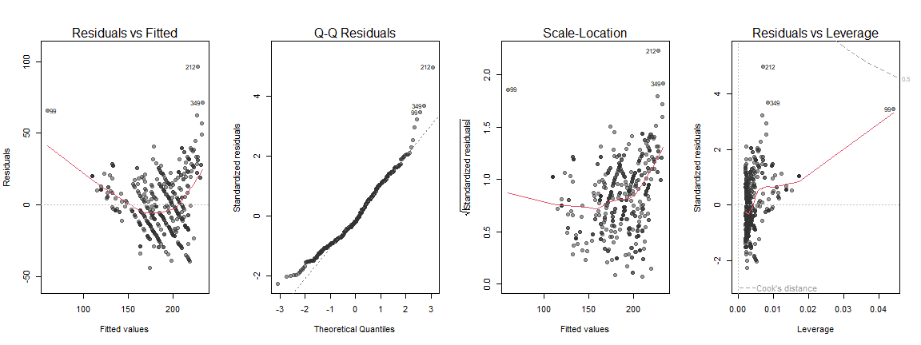
- (4 pts) Use the residuals vs. fitted values plot to make a sketch (hand drawn) of the raw data. Describe why your sketch looks the way it does and discuss any severe violations of modeling assumptions that you have uncovered. My sketch has a curved trend like Rvf plot, and has a wider spread of points the higher the x. It has a severe violation of non-linearity due to the curved shape. Image included in the assignment submission..
You bring your sketch to Katie and she is impressed by your conceptual understanding of residuals. She feels extremely embarrassed she forgot to plot the data before proceeding with a statistical analysis. She creates the following four plots. Use them to answer the following questions.
p1 <- df_ev |>
ggplot(aes(x = acceleration_0_100_s, y = top_speed_kmh)) +
geom_point(alpha = 0.5) +
geom_smooth(method = "lm") +
labs(title = "A")
p2 <- df_ev |>
ggplot(aes(x = log(acceleration_0_100_s), y = top_speed_kmh)) +
geom_point(alpha = 0.5) +
geom_smooth(method = "lm") +
labs(title = "B")
p3 <- df_ev |>
ggplot(aes(x = acceleration_0_100_s, y = log(top_speed_kmh))) +
geom_point(alpha = 0.5) +
geom_smooth(method = "lm") +
labs(title = "C")
p4 <- df_ev |>
ggplot(aes(x = log(acceleration_0_100_s), y = log(top_speed_kmh))) +
geom_point(alpha = 0.5) +
geom_smooth(method = "lm") +
labs(title = "D")
library(patchwork)
p1 + p2 + p3 + p4
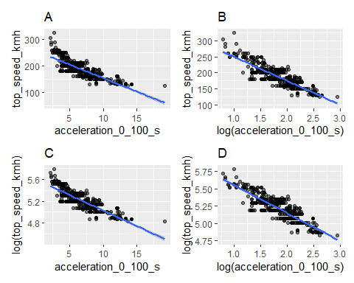
- (4 pts) Which transformation appears to be best for these data? Explain your reasoning, clearly referencing the plots.
- Plot D appears to be the best transformation of the data because it is the most linear point clustering around the regression line. The spread of the points is also consistent along the regression line.
- (20 pts) Fit the most appropriate regression model for investigating the relationship between acceleration from 0 to 100 km/h and EV top speed (km/h). Write up a summary of your analysis that includes the following:
  - The research question, the estimated model used to address the question, and the estimated model summary output.
  - The hypotheses that allow you to address the research question in words and on the tranformed scale (if applicable).
  - A summary of statistical findings that includes an evidence statement and conclusion statement from the hypothesis tests you outlined in (ii). Your evidence statement should include the test statistic, the distribution it assumes under the null hypothesis, and the p-value for the test on the tranformed scale. Your conclusion statement should communicate what you conclude regarding the research question.
  - Provide practical insight about the relationship of interest on the original scale. That is, provide an interpretation of the 95% CI for the parameter of interest on the original scale.
# write code to fit the model you chose in question 6
fit_llspeed <- lm(log(top_speed_kmh) ~ log(acceleration_0_100_s), data = df_ev)
# write code to look at the summary output/conduct a test on the transformed scale
summary(fit_llspeed)
##
## Call:
## lm(formula = log(top_speed_kmh) ~ log(acceleration_0_100_s),
## data = df_ev)
##
## Residuals:
## Min 1Q Median 3Q Max
## -0.247790 -0.060720 -0.006074 0.066746 0.252422
##
## Coefficients:
## Estimate Std. Error t value Pr(>|t|)
## (Intercept) 5.94924 0.01914 310.78 <2e-16
## log(acceleration_0_100_s) -0.40103 0.01011 -39.68 <2e-16
##
## Residual standard error: 0.08743 on 476 degrees of freedom
## Multiple R-squared: 0.7678, Adjusted R-squared: 0.7673
## F-statistic: 1574 on 1 and 476 DF, p-value: < 2.2e-16
# write code to create a 95% CI on the transformed scale
confint(fit_llspeed)
## 2.5 % 97.5 %
## (Intercept) 5.9116240 5.9868552
## log(acceleration_0_100_s) -0.4208894 -0.3811677
# write code to back-transform your CI for interpretation on the original scale
# back-transform the slope CI
exp(confint(fit_llspeed)["log(acceleration_0_100_s)", ])
## 2.5 % 97.5 %
## 0.6564627 0.6830633
- RESPONSE to i: Is there a significant linear relationship between log(acceleration time) and log(top speed) for EV’s? Model: log(top speed) = 5.9492 - 0.4010log(acceleration time)
- RESPONSE to ii: Ho: B1 = 0(no linear relationship) & Ha: B1 != 0(linear relationship)
- RESPONSE to iii: Test statistic = -39.68, which follos a t distribution with 476 df. Associated Pvalue is < 2.2(10^(-16). Since the Pvalue is below a significance level of 0.05, we reject Ho and conclude there is evidence of a strong linear relationship.
- RESPONSE to iv:the The 95% CI for B1 on the transformed scale is (-0.40209, -0.3812) and back transforming gives (0.6565, 0.6831).
Regardless of the model you chose in the previous questions, Katie chooses to fit a log-log model to these data. She writes the code below to generate two figures showing confidence intervals and prediction intervals for the regression model she fit. Use these plots to answer the following questions.
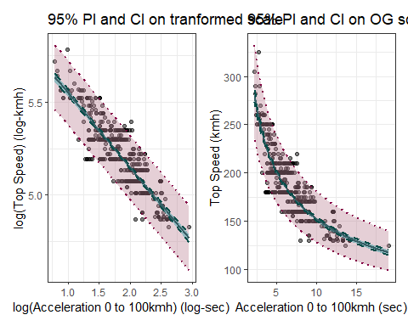
- (2 pts) Which parameter, $μ_{ν}$ or $y_{ν}$, is associated with the prediction intervals displayed in the plots? Briefly explain your reasoning.
- $y_{ν}$ is the parameter associated with the prediction intervals displayed because prediction intervals are meant to predict where a single new observation would fall.
- (4 pts) Use the plot on the original scale to estimate the endpoints of a prediction interval for a new EV with an acceleration from 0 to 100 km/h in 10 seconds. Round to the nearest integer and provide an interpretation of your interval in the context of the problem.
- Looking at the OG plot at x=10 shows a estimated prediction interval of (125, 175)km/h. We are 95% confident that a new individual EV with an acceleration time of 10s will have a top speed between 125 and 175km/h.
- (10 pts) Write code to create the standard diagnostic plots for the log-log regression used in the CI/PI questions. Assess all modeling assumptions that can be assessed using the suite of diagnostic plots to make a judgement on whether you trust the inferences made in Questions 8 & 9.
par(mfrow = c(2, 2))
plot(fit_llspeed, pch = 19, col = rgb(0.2, 0.2, 0.2, 0.5))
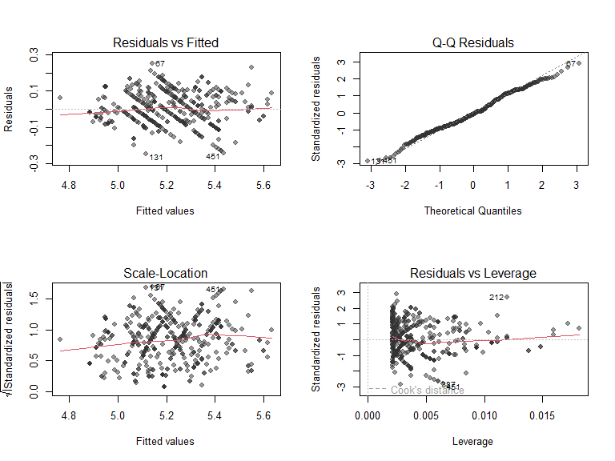
- RvF: the line is nearly flat across the range of fitted values. There is no curve or pattern in the plot, which indicatesthe linearity assumption is satisfied for the log-log model.
- Q-Q: The points follow the line closely with sight deviations in the tails. This suggests that normality is reasonably satisfied.
- Scale-Location: line is nearly flat with slight upward trend, spread also appears to be consistent.Hence the constant variance assumption is reasonably satisfied.
- Residuals vs. Leverage: No points exceed the cooks distance threshold so the assumption that no single point influnces the fit is satisfied.

Finding published literature
- (10 pts) Use either Google Scholar or the MSU Library’s access to Web of Science to find a peer reviewed research article that uses regression (does not need to be simple linear regression) to address a question you find interesting. This could be a scientific question you would investigate related to your major or something you are personally interested in. Provide the abstract of the paper and a complete citation as part of your response to this question. Also briefly describe how the paper used regression to address a question that interests you.
Abstract: In this paper we have described and extended some recent proposals on a general Bayesian methodology for performing record linkage and making inference using the resulting matched units. In particular, we have framed the record linkage process into a formal statistical model which comprises both the matching variables and the other variables included at the inferential stage. This way, the researcher is able to account for the matching process uncertainty in inferential procedures based on probabilistically linked data, and at the same time, he/she is also able to generate a feedback propagation of the information between the working statistical model and the record linkage stage. We have argued that this feedback effect is both essential to eliminate potential biases that otherwise would characterize the resulting linked data inference, and able to im- prove record linkage performances. The practical implementation of the procedure is based on the use of standard Bayesian computational techniques, such as Markov Chain Monte Carlo algorithms. Although the methodology is quite general, we have restricted our analysis to the popular and important case of multiple linear regression set-up for expository convenience.
Citation: Liseo, B., & Tancredi, A. (2011). Bayesian estimation of population size via linkage of multivariate normal data sets. Journal of Official Statistics
The paper used regression to solve a interesting problem. That problem being record linkage, where matching records about the same individual across two or more datasets that lack a common identifer.

